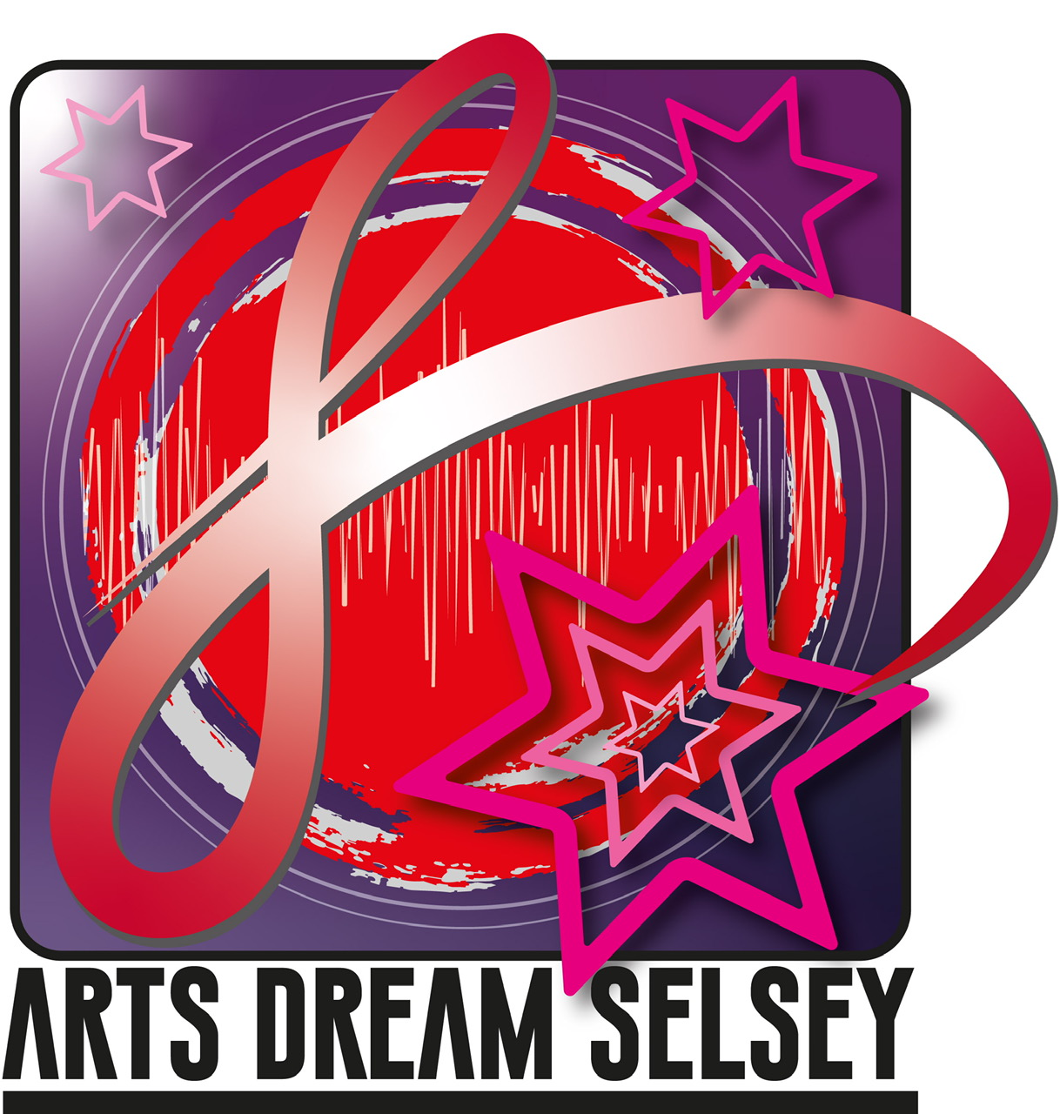

Arts Dream Selsey Communications Policy
Charity no- 1155713
Company no- 8857997

Through this policy ADS provides a framework for all its communication activities internally and with the external environment. The aim of the policy is to set out the thinking that ADS employs to communicate its charity objectives, its projects and philosophy with its funders and users. By delivering messages clearly, there is no room for misunderstanding or alteration of intent

This will allow ADS to:
- Demonstrate its achievements
- Raise awareness of ADS locally, regionally and nationally
- Engage effectively with a range of different Stakeholders
- Demonstrate the success of its work.

Communications

There are two target audiences for ADS communications:

- External: The local community in Selsey and the wider manhood Peninsula, local regional and national organisations, collaborators, funding bodies and local, and regional users
- Internal: ADS trustees, staff and volunteers.
- ADS employees a variety of communication methods. These include:
- Website.
- Various Newsletters.
- Publications, articles and press releases for publication in local and regional media outlets
- Occasional interviews on local radio.
- Social media
- Twitter
- YouTube.
- Publicity material displayed around the Manhood Peninsular
- Internal and external correspondence though email and ADS mailing list
- Reports for trustees.
- Minutes or notes of meetings.
- Events

Social Media

ADS operates a number of different social media platforms, to include:
- Arts Dream Sesley main face book page
- Arts Dream Selsey Artists facebook page
- Selsey Swing Jive
- Selsey 57 face book page
- Out of the Ashes face book page
- Selsey Community Choir face book page ( closed group)
- Sing Your Heart Out facebook page (closed group )
- Adventure facebook page (closed group)

Responsibilities

In order to ensure coherence and quality of communications released by ADS a few nominated Trustees release communication to the wider public. All reports, briefs and evaluations are checked for consistency by the director of ADS. This also applies to its social Media platforms. To ensure the coherence of the ADS brand all visual material is also checked for consistency, with ADS using an identified professional designer for all of its external visual material

Guidance

To present a consistent image, communications with both external and internal audiences should be of equal standard over all mediums and there should be no contradiction
between different mediums. All communications, including internal emails, reports and notes of meetings should:

- Reflect the principles of confidentiality, data protection and other relevant legislation
Where practical, be accessible by those with disability, impairment or sensory loss
- Be relevant, factually correct, sensitive and timely
- Enable meaningful engagement with partners and other external organisations.
- Recognise the importance and value of engaging with trustees, staff, volunteers and service users
- ADS respects and operates within copyright laws
- No copyrighted material owned by third parties is to be published in any ADS communication unless permitted in writing by that third party
- Where appropriate, credit for text and photos is to be given
- Confidentiality, particularly in relation to trustees, staff, volunteers and service users must be upheld
- Material from websites can be used if the website has sharing buttons or functions
- Events. Where reasonably possible, suitable banners and marketing materials should be made available for use at events and activities involving ADS
- Enhances its visual and text based communication on advice from users and partners.

Requirements

- All communications intended for the external audience should bear the ADS logo.
- All ADS projects will have an identified budget for Marketing and Communication
- For specific projects ADS will consult with an external funding agency
- ADS will take a proactive approach to communication and ensure that materials are sent out in a timely manner and are accessible via as many media sources as possible, including social media platforms
- ADS will endeavour to build excellent relationships with the press to develop effective communication with the community

Advice on using Social Media

ADS will maintain its charity standard’s on all its social media posting, and will adhere to the following guidelines:

- Think before you post. Assume that what you post could be shared and read by anyone.
- Think about who can see what you share and manage your privacy settings accordingly. Remember that privacy settings cannot guarantee that something you post will not be publicly visible.
- Maintain appropriate professional boundaries if you communicate with colleagues, service users or other stakeholders
- Do not post confidential or service user identifiable information.
- Do not post inappropriate or offensive material. Link always to ADS Child Protection and Vulnerable Adults Policy, ADS Data Protection Policy and Equal Opportunities Policy
- Use professional judgement about whether something you share falls below the professional standards of the charity
- Photographs or images of individuals are not to be posted without their express permission.
- The charity, its trustees, staff and volunteers, service users or external partner organisations should not be defamed
- Social Media posts that could bring the charity into disrepute are to be avoided.
- Seek advice from the Director of ADS in regard to any of the above

Chris Butler
January 20th 2021

